Perform two-way Anova

Aniket Roy and Kruitk Shah

15/10/2020

# Example

Moth dataset are stored in csv file and then reading csv file to get data from csv file.

data1 <- read.csv('moth.csv')  
data1

## X28 Top Scent  
## 1 19 Top Scent  
## 2 32 Top Scent  
## 3 15 Top Scent  
## 4 13 Top Scent  
## 5 35 Top Sugar  
## 6 22 Top Sugar  
## 7 33 Top Sugar  
## 8 21 Top Sugar  
## 9 17 Top Sugar  
## 10 31 Middle Scent  
## 11 21 Middle Scent  
## 12 14 Middle Scent  
## 13 18 Middle Scent  
## 14 24 Middle Scent  
## 15 25 Middle Sugar  
## 16 12 Middle Sugar  
## 17 19 Middle Sugar  
## 18 21 Middle Sugar  
## 19 27 Middle Sugar  
## 20 21 Middle Scent  
## 21 34 Middle Scent  
## 22 32 Middle Scent  
## 23 11 Middle Scent  
## 24 10 Bottom Scent  
## 25 39 Bottom Sugar  
## 26 37 Bottom Sugar  
## 27 30 Bottom Sugar  
## 28 22 Bottom Sugar  
## 29 28 Bottom Sugar

data2<-data.frame("Moth"=data1[,1],"Position"=data1[,2],"lure"=data1[,3])  
data2

## Moth Position lure  
## 1 19 Top Scent  
## 2 32 Top Scent  
## 3 15 Top Scent  
## 4 13 Top Scent  
## 5 35 Top Sugar  
## 6 22 Top Sugar  
## 7 33 Top Sugar  
## 8 21 Top Sugar  
## 9 17 Top Sugar  
## 10 31 Middle Scent  
## 11 21 Middle Scent  
## 12 14 Middle Scent  
## 13 18 Middle Scent  
## 14 24 Middle Scent  
## 15 25 Middle Sugar  
## 16 12 Middle Sugar  
## 17 19 Middle Sugar  
## 18 21 Middle Sugar  
## 19 27 Middle Sugar  
## 20 21 Middle Scent  
## 21 34 Middle Scent  
## 22 32 Middle Scent  
## 23 11 Middle Scent  
## 24 10 Bottom Scent  
## 25 39 Bottom Sugar  
## 26 37 Bottom Sugar  
## 27 30 Bottom Sugar  
## 28 22 Bottom Sugar  
## 29 28 Bottom Sugar

## The hypothesis testing problem is:

**H0:There is no Significance difference between means of all**

**H1:There is a significant difference among means of all.**

*To check the normality of a data we have to do the shapiro test*

res <- shapiro.test(data2$Moth)  
res

##   
## Shapiro-Wilk normality test  
##   
## data: data2$Moth  
## W = 0.96219, p-value = 0.3717

# Testing Normality Graphically

qqnorm(data2$Moth)

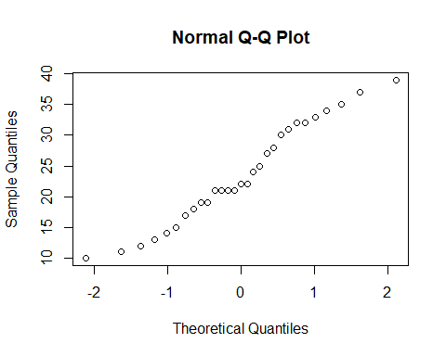

**Bartlett’s test is used to test if k samples have equal variances. Equal variances across samples is called homogeneity of variances.**

bartlett.test(Moth~Position,data=data2)

##   
## Bartlett test of homogeneity of variances  
##   
## data: Moth by Position  
## Bartlett's K-squared = 1.1313, df = 2, p-value = 0.568

bartlett.test(Moth~lure,data=data2)

##   
## Bartlett test of homogeneity of variances  
##   
## data: Moth by lure  
## Bartlett's K-squared = 0.059131, df = 1, p-value = 0.8079

Here in moth by position p-vlaue is 0.568 which is greater than 0.05 so we accept NULL Hypothesis. And in moth by lure p-value is 0.8079 which is greater than 0.05 so we accept NULL Hypothesis.

twoway <- aov(Moth~Position+lure,data=data2)  
summary(twoway)

## Df Sum Sq Mean Sq F value Pr(>F)  
## Position 2 132.1 66.06 0.974 0.391  
## lure 1 91.5 91.50 1.349 0.256  
## Residuals 25 1695.5 67.82

twoway

## Call:  
## aov(formula = Moth ~ Position + lure, data = data2)  
##   
## Terms:  
## Position lure Residuals  
## Sum of Squares 132.1248 91.5042 1695.5435  
## Deg. of Freedom 2 1 25  
##   
## Residual standard error: 8.235395  
## Estimated effects may be unbalanced

TK <- TukeyHSD(twoway,"Position")  
TK

## Tukey multiple comparisons of means  
## 95% family-wise confidence level  
##   
## Fit: aov(formula = Moth ~ Position + lure, data = data2)  
##   
## $Position  
## diff lwr upr p adj  
## Middle-Bottom -5.5238095 -15.533115 4.485495 0.3690257  
## Top-Bottom -4.6666667 -15.477952 6.144618 0.5378869  
## Top-Middle 0.8571429 -7.906955 9.621241 0.9678568

plot(TK)

